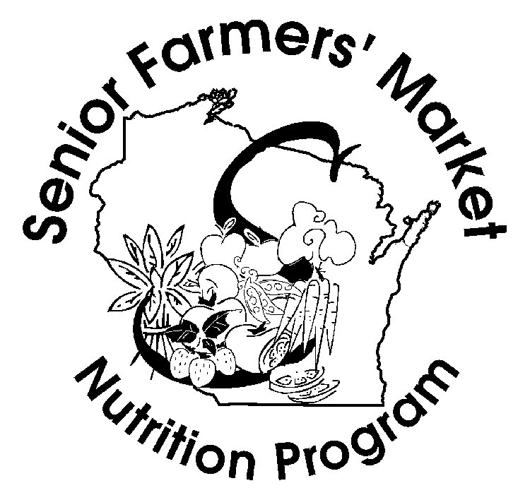

We are happy to announce that Bayfield County Department of Human Services still has Senior Farmer’s Market Nutrition Program Vouchers available for Bayfield County residents who meet the criteria below. The goal of this program is to help seniors improve their diets with fresh produce while giving local farmers more business and adding support to the local economy.

To be eligible for the program in Bayfield County, you must be a Bayfield County resident, 60 or older (55 or older if you are Native American), and, at or below 185% of the Federal Poverty Limit (FPL). For a one-person household, 185% FPL is $2,248/month. For a two- person household, 185% FPL is $3,041/month. For each additional household member, add $793/month. Income is self-declared; you do not need to show verification of income.

If eligible, you will receive one set of vouchers worth $35, with a limit of one set per person. New in 2023 is that each person in a household may qualify for a set of vouchers. All vouchers will be distributed on a “first come first served” basis based on when the signed and completed eligibility form is received by Bayfield County DHS either by mail or in person. One form is needed for each participant.

If you are eligible and interested in receiving the SFMNP vouchers, please call 715-373-3355 and ask for an application to be sent to you in the mail.