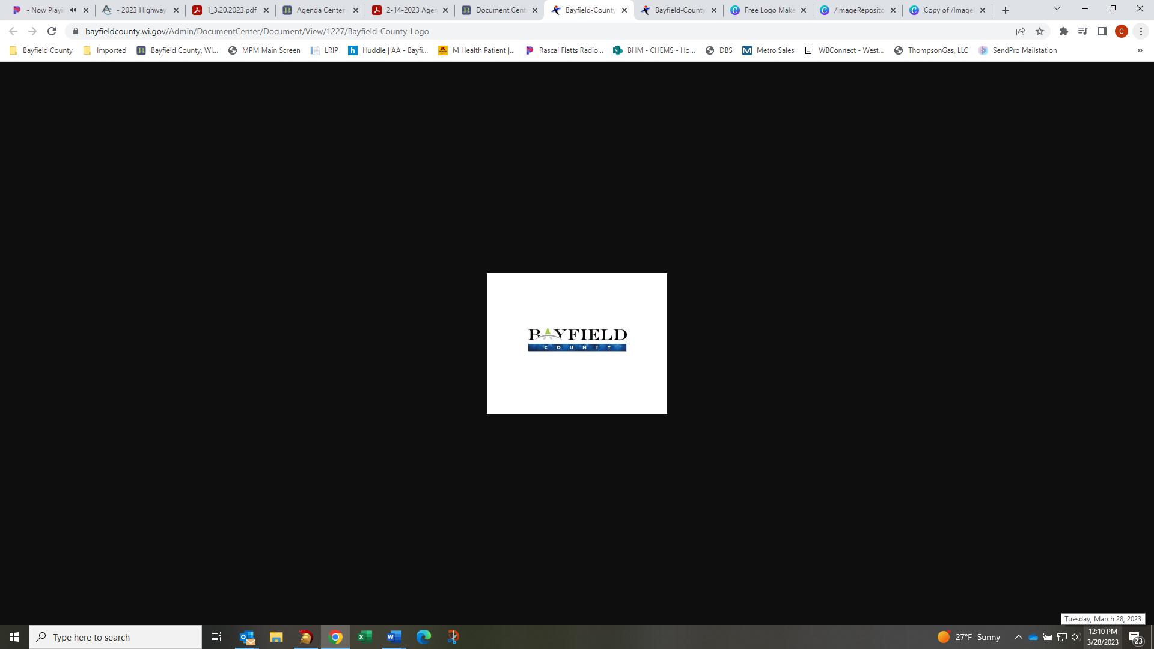
Bayfield County Highway Department
PO Box 428, Washburn, WI 54891
Phone: 715-373-6115 Fax: 715-373-6140
E-Mail: highway@bayfieldcounty.wi.gov

April 22, 2025

NEWS RELEASE - PUBLIC SERVICE ANNOUNCEMENT

NOTICE

PURSUANT TO SECTION 349.16 OF THE WISCONSIN STATUTES
SEASONAL WEIGHT RESTRICTIONS ARE BEING REMOVED
ON ALL BAYFIELD COUNTY TRUNK HIGHWAYS
EFFECTIVE: 12:00 p.m. (Noon) – THURSDAY, MAY 01, 2025

Jacob Benson
Jacob Benson, Highway Commissioner
Bayfield County Highway Department

nu

